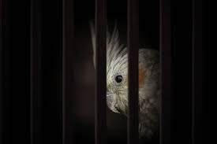

**OUR RIGHTS**

Beyond the delinquent ingot the parakeet stood,

Bisected from the Gaia and her neighborhood.

Tacitly she wept at her incarcerated state.

The avaricious mankind had subdued her fate.

She sighed gazing at the infinite Zeus,

Where she spanned her wings and glided in truce.

Her plumage dazzled in Phoebus' mellow shaft;

Her tranquil eyes and lambent beak erected in apt.

Her silence made her a slave of human prejudice,

Her liberty and rights were battered before her eyes.

Amidst what is detailed in part III of our Constitution book;

Our rights are covertly snatched by hook or by crook.

By revolting them back we can salvage,

Because tolerating injustice can turn us into a bird in cage.

- Aadityaamlan Panda